Cities Research Institute

Yiping Yan

Telephone + 61 0406081735
Email: yiping.yan@griffithuni.edu.au
16 May 2022

2022 Selection Committee
Young Professionals Award
AITPM
aitpm@aitpm.com.au

NOMINATION – AITPM 2022 YOUNG PROFESSIONALS AWARD

I am writing to nominate for this year’s AITPM Young Professionals Award. I have been involved in AITPM activities for around four years now and would be delighted to be considered for this prize.
My Interests: I have been pursuing a career as a transport professional since first undertaking Dr Barbara Yen’s Transport Engineering course in my Civil Engineering undergraduate degree at Griffith University in 2017. This sparked my interest and I am so glad she took the time to talk to me about career options in transport planning and engineering. Dr Yen introduced me Griffith’s transport research team members and encouraged me to consider transport as a focus. My interest was so strong I decided to commute from the Gold Coast to Nathan campus every week to do my Final Year Project with Prof Matthew Burke and Dr Abraham Leung and hang out with their transport PhD students up in Brisbane. They had just moved into the Sir Samuel Griffiths Centre, a flagship research building for the university, and a great place to study. That’s when I went to my first AITPM events. I then decided to apply for a PhD in transport modelling at Griffith. This was on a topic working with and for the Qld Department of Transport and Main Roads, with Mitch Baskerville’s support. That PhD is currently under examination, but I’ve already secured a great job as a transport modeller with Transurban.
My Achievements: I have had a series of achievements that I’m proud of whilst a student at Griffith University. These include:
- Securing a ‘7’ (out of 7) ranking in my transport engineering class;
- Getting First Class Honours then being awarded the University Medal
- Securing a highly competitive Griffith University International Postgraduate Research Scholarship (GUIPRS) to fully fund my PhD studies, including tuition and living expenses;
- Having a media article on my PhD research published by the ABC and having over 100,000 online readers, one of Griffith University’s most-read articles that year;
- Having my papers published in key conferences and journals, including a paper that will soon appear in the Journal of Transport and Land Use (a top quartile journal from Elsevier);
- Securing a strategic modeller position in the traffic forecasting team at Transurban straight out of university.
Advancing Transport Issues: I made a point of not just wanting to do research for research’s sake. I volunteered to do a new type of PhD that Griffith’s team was trialling, where the student is placed within government or industry, to help solve real-world problems. In my case, it was to help improve some issues in the mode choice modelling used in the Brisbane and South East Queensland Travel Demand Models (the BSTM and SEQ-STM, respectively). Prior to COVID, I was placed one to two-days per week with Jaco Van Den Berg’s modelling team at 61 Mary Street, in Brisbane. We were trying to find ways to improve the market segmentation used for both school trips and commute trips. This new approach has now been adopted and formalised across all of Griffith in what is called the “iPhD” scheme – a set of industry-focused PhD embedded in industry. I’m really pleased I was one of the first transport students to work this way in the current era.
I also made a point of coming with the Griffith team to many AITPM events, from my honours year in 2018 onwards. It was through AITPM that I met Tim Veitch and Pedro Camargo of VLC, and John Morris of GTA Consultants (now Stantec) who really helped me with my PhD!
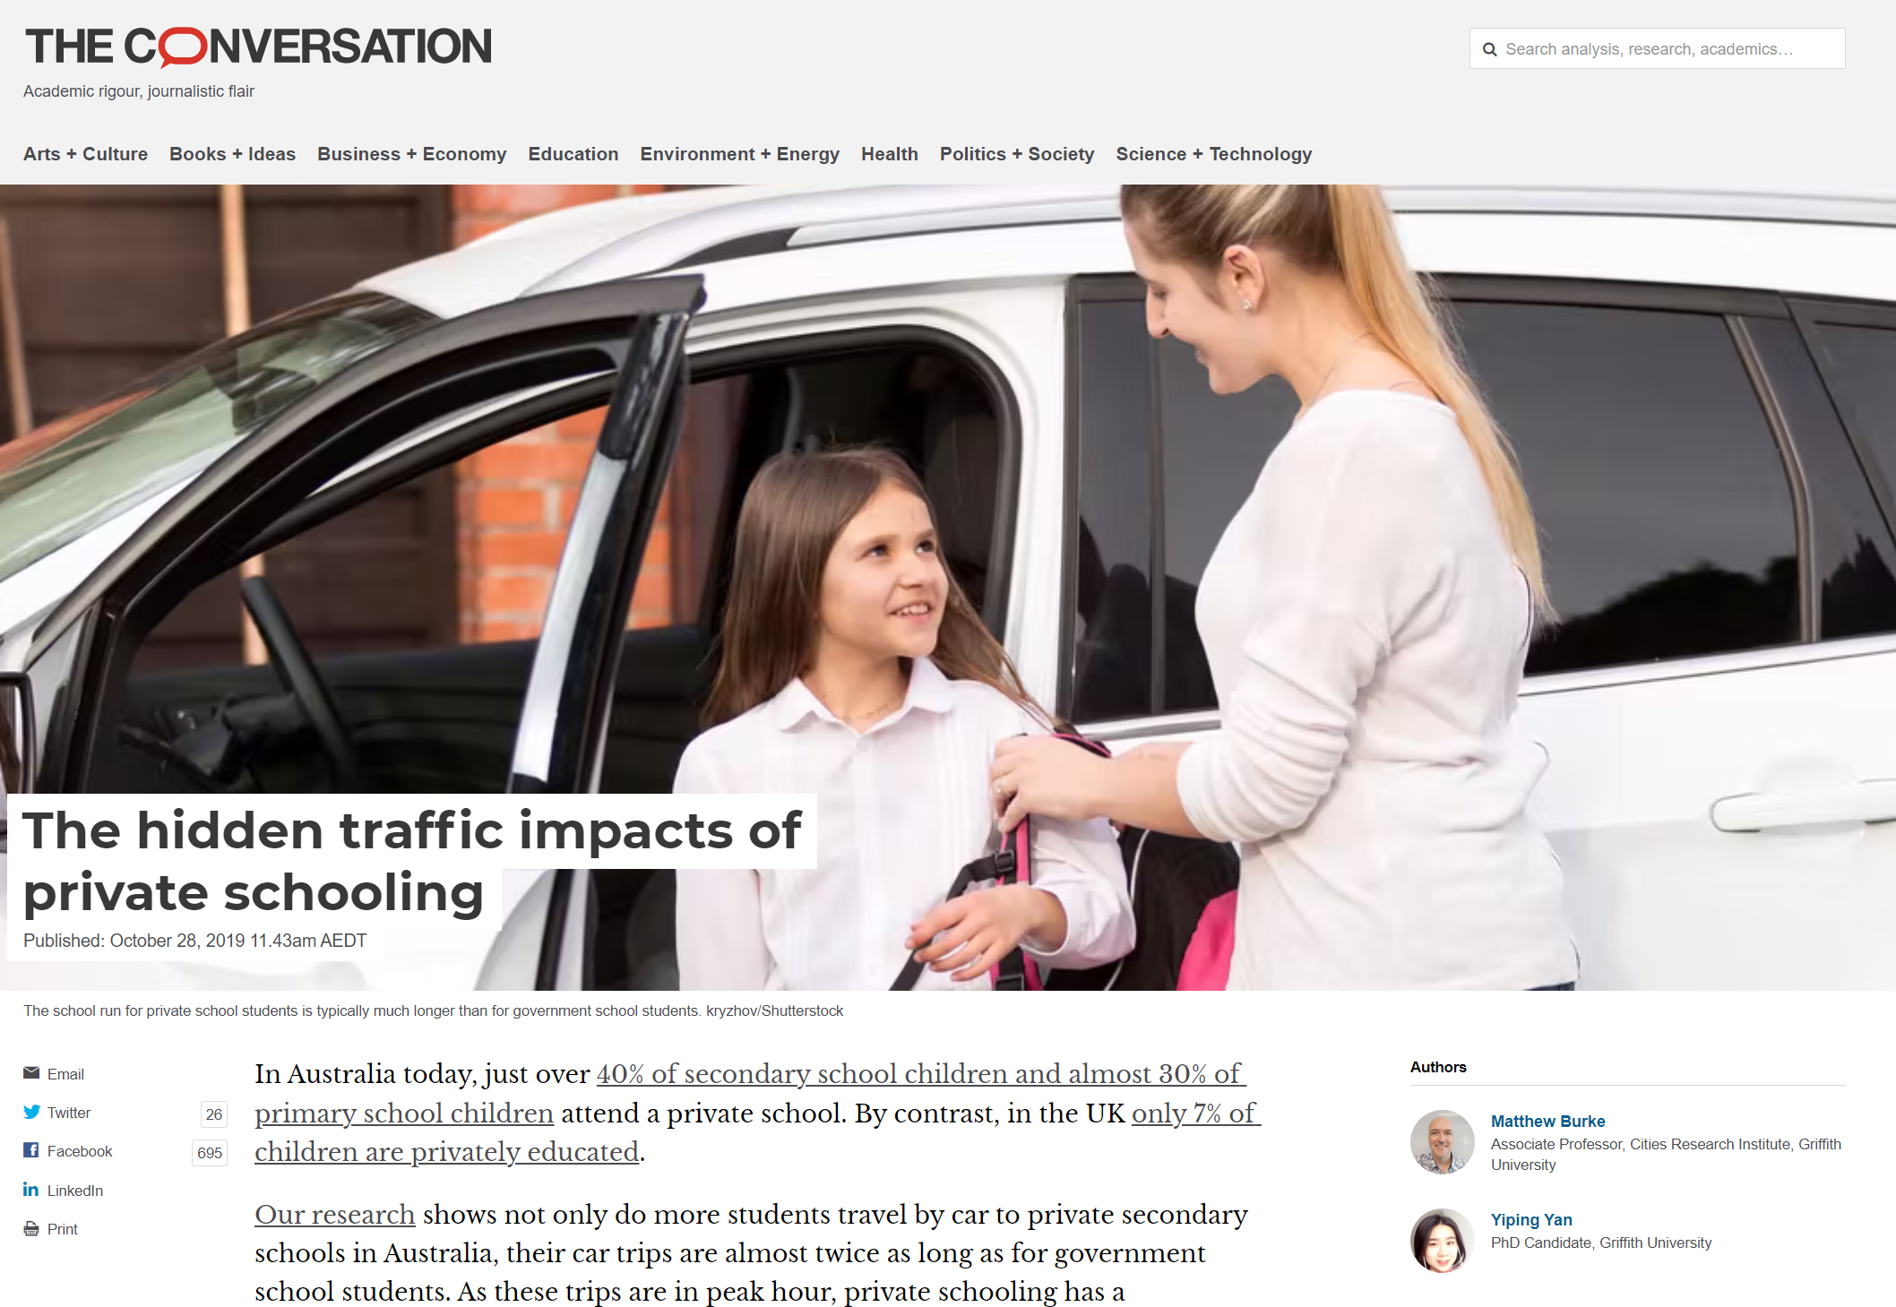
Yes, I have presented my work at conferences like the World Symposium on Transport and Land Use Research and the Australasian Transport Research Forum. But I also chose to put my research findings out to broader audiences. I put together an article, first published in The Conversation, then in ABC Online, that went viral. It’s had well over 110,000 views and was subject to follow-up radio interviews and commentary. I was interviewed on Kat Feeney’s Queensland-wide radio show and got to meet B1 and B2 at the ABC studios at Southbank (see the next page).
Even today I am still speaking to different groups about transport issues. On the 4th of April this year I spoke to the Lyceum Club in Brisbane about my work on the hidden biases that may exist for women in transport planning, building on my work on outdated white and blue collar market segmentations.

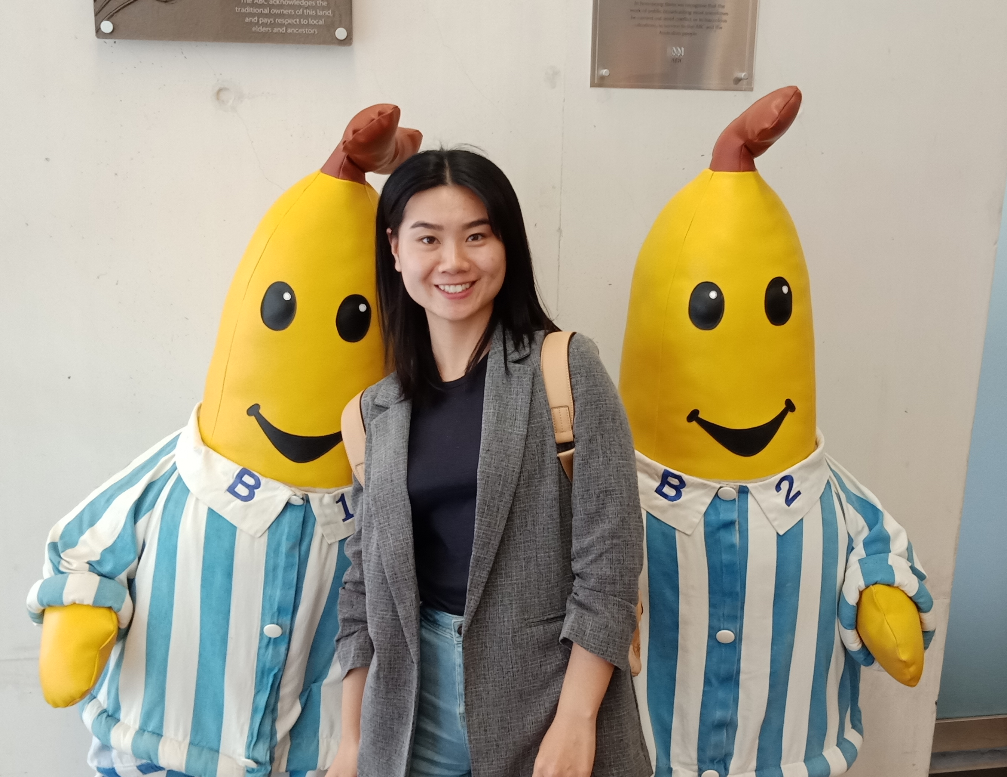
Recent Challenges: I went to visit my family just outside the city of Wuhan in January 2020 for the Chinese New Year festival. Unfortunately, I went through the entire Hubei Province lockdown at the very start of the pandemic. By the time that lockdown ended, the Australian borders were shut to international students. I couldn’t return to the transport team at Griffith, or my work placement at TMR in Qld Government. Thankfully, Prof Pan Haixiao, who hosted the last World Conference on Transport Research at Tongji University in Shanghai, offered me a visiting student fellowship position. Tongji is ranked Number 7 in the world in the current rankings for ‘transportation science and technology’; Griffith is ranked in the top-200. I spent a year in Shanghai until, thanks to folks at TMR, I was able to get an exemption to Australia’s border restrictions and return to Griffith to complete my PhD. That I was able to maintain my work efficiency and complete my PhD under these circumstances was a great achievement.
Benefits going to AITPM’s National Conference: I am now in an enviable position as one of the young female engineers in the transportation field here in Australia. Though I have slowly built up my contacts within the Queensland transport community. I know a few academics in other cities, and some Transurban people. But I really don’t know folks in other states, nor the transport planning and modelling challenges they are facing. I don’t know the other young female transport engineers and planners like me (we need to support one another!). I want to use this conference to help build that network of support – not just for me but for others – of people who I might collaborate with for the next thirty years of my career.
Branch Involvement: I would be very happy to serve you on the Queensland Young Professionals Network Committee if given this award. I am also very happy to attend and meaningfully contribute as I can to the Queensland Branch Committee, if invited after this award.
If you require further information about this nomination, please feel free to call me at the details above.
Yours sincerely,

Ms Yiping Yan

